# CS 255 System Design Document

## UML Diagrams

### UML Use Case Diagram

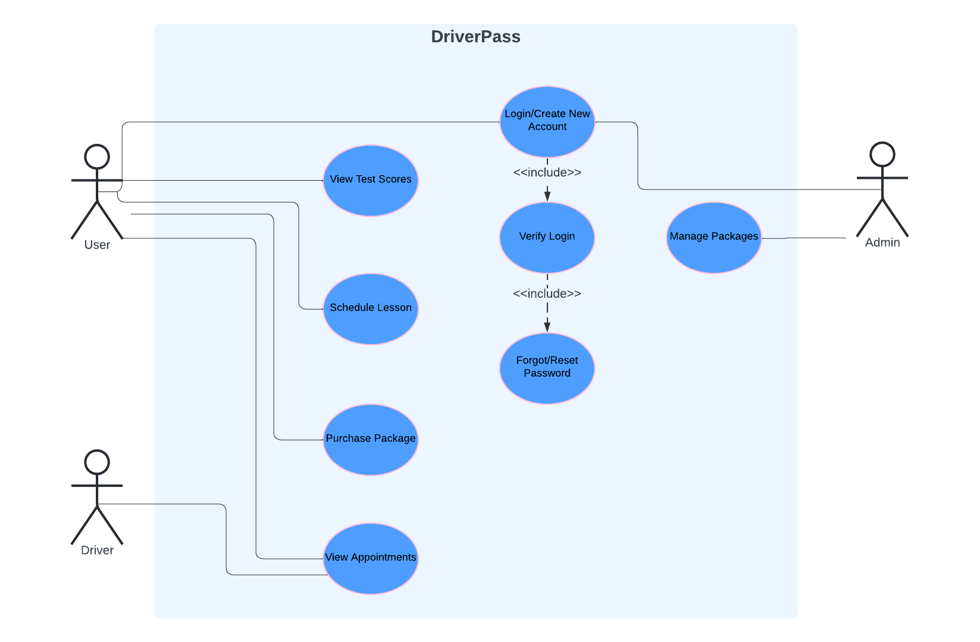

### UML Activity Diagrams

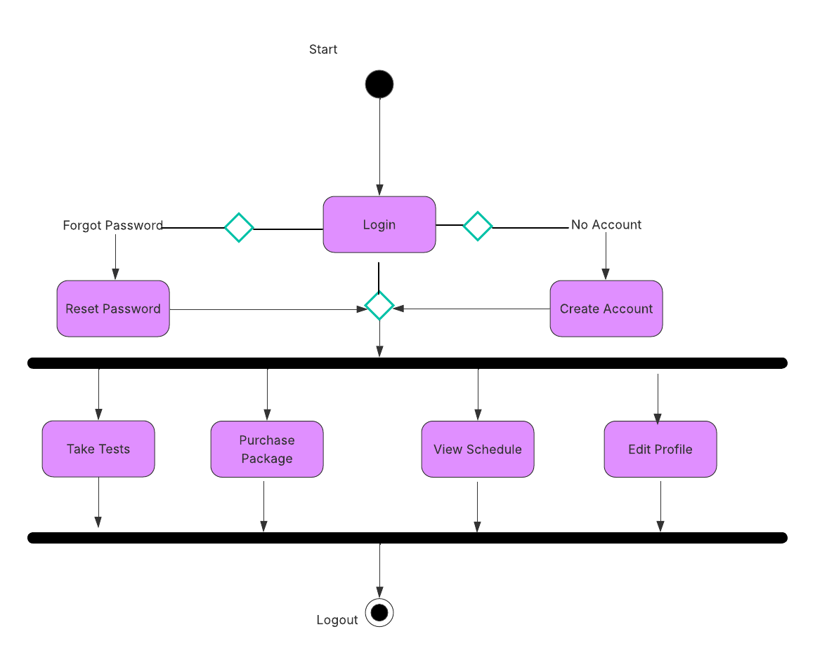

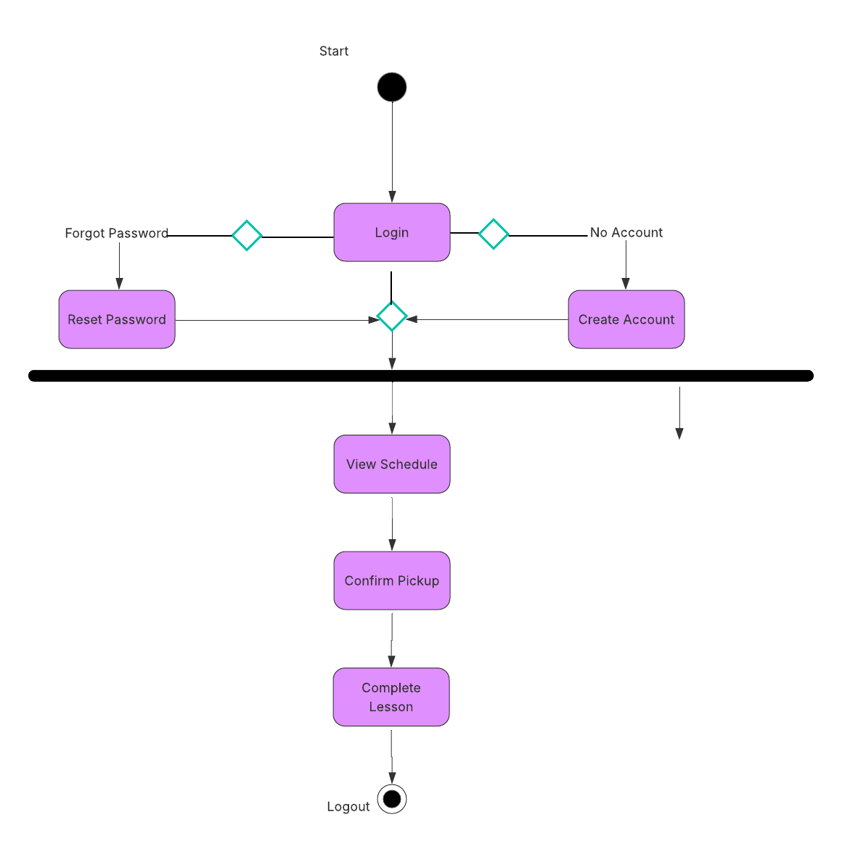

### UML Sequence Diagram

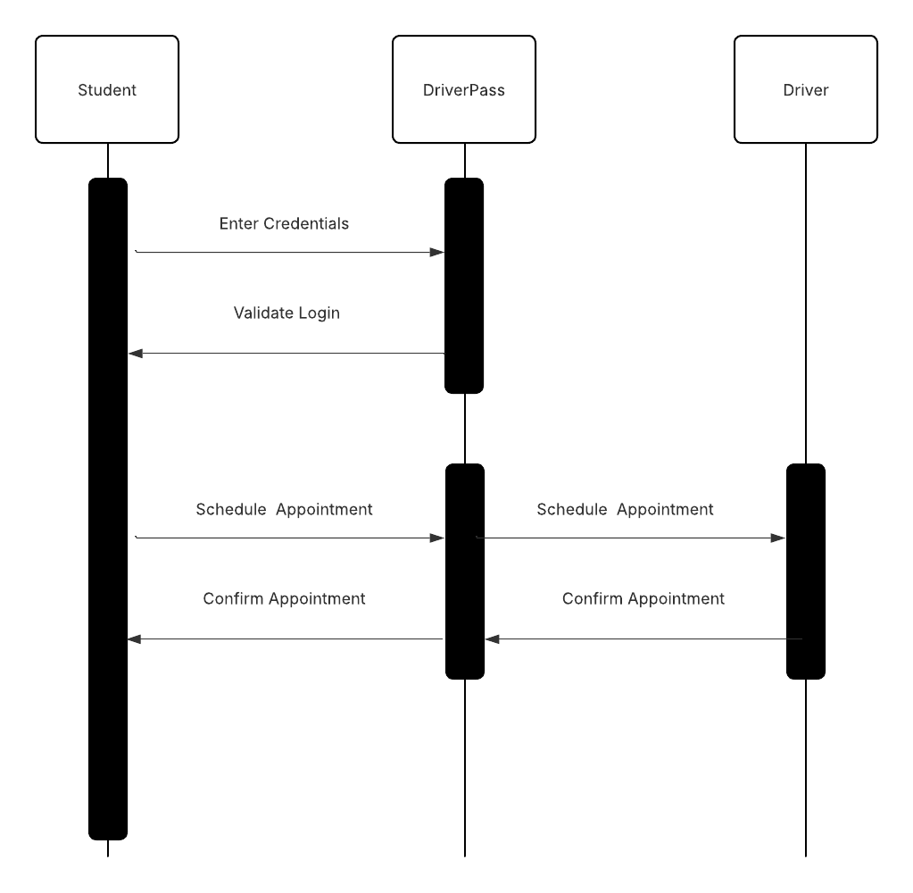

### UML Class Diagram

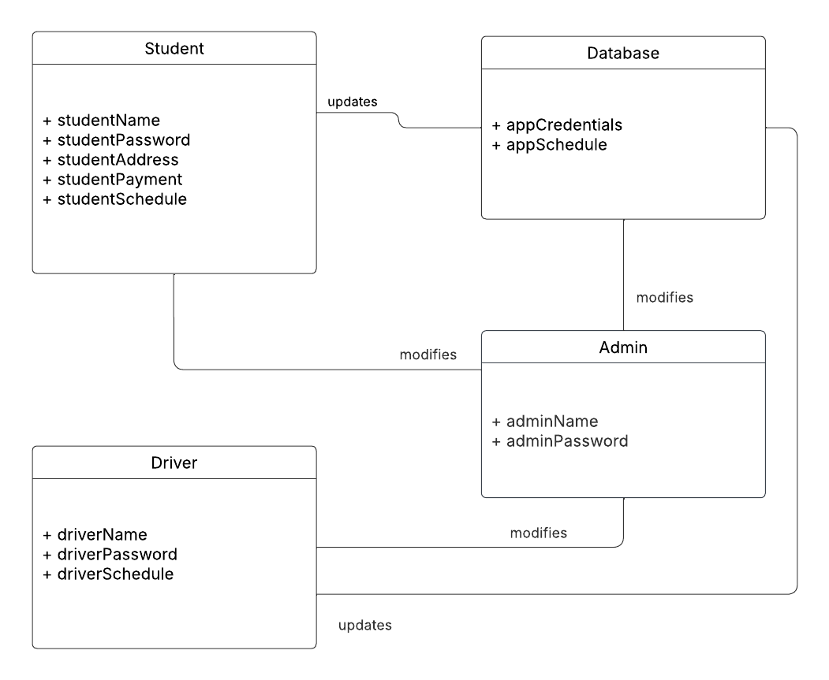

## Technical Requirements

This system will need to be run on a web-based platform with data supplied by a cloud-based database. The nature of such a platform will facilitate the utmost compatibility, and such a database will make take care of most security concerns as well as provide an easily accessible, perpetual database that contains all data from each individual user (driver, admin, student, etc). The front end may be created using primarily JavaScript (React), HTML, and CSS while the backend may be provided by a cloud service such as AWS.